Serial No. | Questions | CO | Bloom’s Taxonomy Level | Difficulty Level | Competitive Exam Question Y/N | Area | Topic | Unit | Marks
1 | Define ordinary differential equation and give an example. | CO4 | K1 | Low | N | ordinary differential equation | Definition | 4 | 2
2 | Define order and degree of ordinary differential equation | CO4 | K1 | Low | N | ordinary differential equation | order and degree | 4 | 2
3 | Identify order and degree in each of the following differential equations  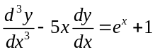 | CO4 | K2 | Medium | N | ordinary differential equation | order and degree | 4 | 2
4 | Identify order and degree in each of the following differential equations  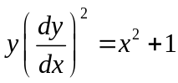 | CO4 | K2 | Medium | N | ordinary differential equation | order and degree | 4 | 2
5 | Define general and particular solution of the ODE. | CO4 | K1 | Medium | N | Type of solution | Definition | 4 | 2
6 | Show that 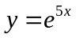 is the particular solution of the ODE 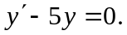 | CO4 | K2 | Low | N | Type of solution | Verifying of type of solution | 4 | 2
7 | Verify that 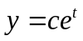is the general solution of the differential equation  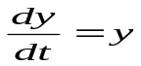. | CO4 | K2 | Medium | N | Type of solution | Verifying of type of solution | 4 | 2
8 | What is the necessary and sufficient condition for 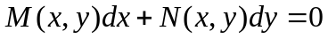  to be an exact differential equation. | CO4 | K1 | Low | N | Exact ODE of first order | necessary and sufficient condition for exactness | 4 | 2
9 | Determine the exactness of the differential equation 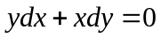. | CO4 | K2 | Low | N | Exact ODE of first order | Checking of exactness | 4 | 2
10 | Find the solution of the differential equation 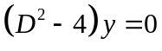. | CO4 | K2 | Medium | N | Homogeneous linear differential equation with constant coefficients | Complementary function | 4 | 2
11 | For the initial value problem 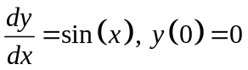  Find the value of y at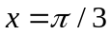.  (Gate 2017) | CO4 | K2 | Low | Y | Differential equation with constant coefficient | Solution of differential equation | 4 | 2
12 | Define linearly independent of two functions. | CO4 | K1 | Medium | N | Homogeneous linear differential equation with constant coefficient | Independency | 4 | 2
13 | Is y(x)=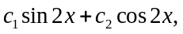 where 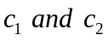 are arbitrary constants, a solution of  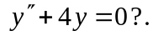 | CO4 | K2 | Medium | N | Homogeneous linear differential equation with constant coefficient | Solution of differential equation | 4 | 2
14 | Find the P.I of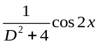 | CO4 | K2 | High | N | Non-Homogeneous linear differential equation with constant coefficients | Particular integral | 4 | 2
15 | Find PI of 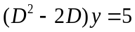. | CO4 | K2 | High | N | Non-Homogeneous linear differential equation with constant coefficients | Particular integral | 4 | 2
16 | Solve the differential equation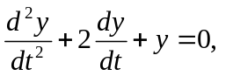  (Gate 2008) | CO4 | K2 | Medium | Y | Homogeneous linear differential equation with constant coefficients | Complementary function (Repeated roots) | 4 | 2
17 | Find the general solution of second order linear homogeneous differential equation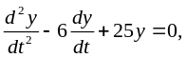 (Gate2018) | CO4 | K2 | Medium | Y | Homogeneous linear differential equation with constant coefficients | Complementary function (Real and distinct roots) | 4 | 2
18 | Determine whether the differential equation  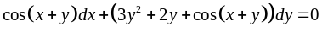 is exact, If exact solve it. | CO4 | K2 | Medium | N | Exact ODE of first order | Test and Solution | 4 | 6
19 | Determine whether the differential equation  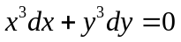is exact, If exact, solve it. | CO4 | K2 | Medium | N | Exact ODE of first order | Solution | 4 | 6
20 | Determine whether the differential equation  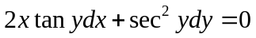is exact, If exact, solve it. | CO4 | K2 | Medium | N | Exact ODE of first order | Solution | 4 | 6
21 | Determine whether the differential equation  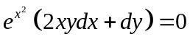is exact, If exact, solve it. | CO4 | K2 | Medium | N | Exact ODE of first order | Solution | 4 | 6
22 | Solve:  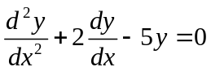  (Gate 2017) | CO4 | K3 | High | Y | Homogeneous linear differential equation with constant coefficients | Complementary function (complex roots) | 4 | 6
23 | Solve the differential equation 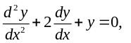 given that y=0 and 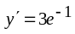  at x=0,Find y(2).(Gate 2016) | CO4 | K3 | Medium | Y | Homogeneous linear differential equation with constant coefficients | Complementary function (Repeated roots) | 4 | 6
24 | Solve:  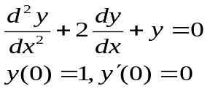  Gate 2016) | CO4 | K3 | Medium | Y | Homogeneous linear differential equation with constant coefficients | Complementary function (Repeated roots) | 4 | 6
25 | Solve the differential equation 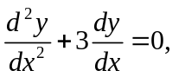 given that y=0 and 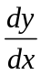=1  at x=0.(Gate 2018) | CO4 | K3 | Medium | Y | Homogeneous linear differential equation with constant coefficients | Complementary function (Real and distinct roots) | 4 | 6
26 | A function y(t) satisfies the differential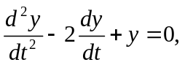  and subjected to initial conditions y(t=0)=0 and dy/dt(t=0)=1.Then find y(t=1).  (Gate2013) | CO4 | K3 | Medium | Y | Homogeneous linear differential equation with constant coefficients | Complementary function (Real and distinct roots) | 4 | 6
27 | Consider the second order linear ordinary differential equation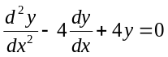, with the boundary conditions 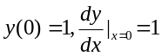.  Find the value of at x=1. (GATE 2016) | CO4 | K2 | Medium | Y | Homogeneous linear differential equation with constant coefficients | Complementary function (Repeated roots) | 4 | 6
28 | Find the particular solution of the differential equation 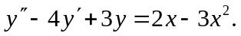  (Gate 2017) | CO4 | K2 | Medium | Y | Non-Homogeneous linear differential equation with constant coefficients | particular solution | 4 | 6
29 | Solve:  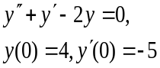 | CO4 | K2 | Medium | N | Homogeneous linear differential equation with constant coefficients | Complementary function (Real and distinct roots) | 4 | 6
30 | Solve:  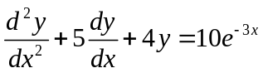 | CO4 | K3 | High | N | Non-homogeneous linear differential equation with constant coefficients | CF and PI | 4 | 6
31 | Solve:  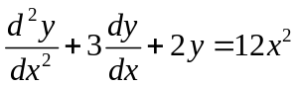 | CO4 | K3 | High | N | Non-homogeneous linear differential equation with constant coefficients | CF and PI | 4 | 6
32 | Solve:  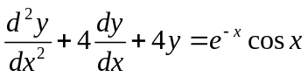 | CO4 | K3 | High | N | Non-homogeneous linear differential equation with constant coefficients | CF and PI | 4 | 6
33 | Solve:  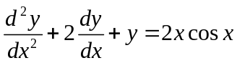 | CO4 | K3 | High | N | Non-homogeneous linear differential equation with constant coefficients | CF and PI | 4 | 6
34 | Solve:  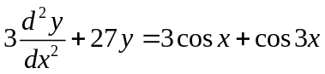 | CO4 | K3 | High | N | Non-homogeneous linear differential equation with constant coefficients | CF and PI | 4 | 6
35 | Solve:  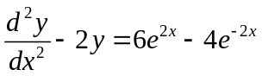 | CO4 | K3 | High | N | Non-homogeneous linear differential equation with constant coefficients | CF and PI | 4 | 6
36 | Solve the non homogeneous ODE by method of variation of parameter: 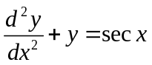 | CO4 | K3 | High | N | Non-homogeneous linear differential equation with constant coefficients | Variation of parameter | 4 | 6
37 | Find the solution of the differential equation  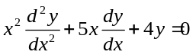  (Gate 2017) | CO4 | K3 | Medium | Y | Homogeneous linear differential equation with variable coefficients | Cauchy-Euler equation | 4 | 6
38 | Solve:  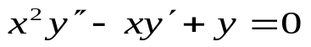 | CO4 | K3 | Medium | N | Homogeneous linear differential equation with variable coefficients | Cauchy-Euler equation | 4 | 6
39 | Find the current 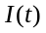 in the -circuit with the following data assuming initial current and charge: L=2 Henry, C= 0.005 Farad and E=220 Sin 4t volts. | CO4 | K3 | Medium | N | Application of Linear Differential Equations to Electric circuits | LC –CIRCUIT | 4 | 6
40 | The equation of an 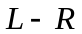 circuit is given by 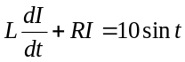.  If 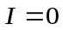at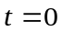, express as a function of. | CO4 | K3 | Low | N | Application of Linear Differential Equations to Electric circuits | LR CIRCUIT | 4 | 6
41 | A resistance of 100 ohms and an inductance of 0.5 Henry are connected in series with a battery of 20 volts. Find the current in a circuit as a function of t. | CO4 | K3 | Medium | N | Application of Linear Differential Equations to Electric circuits | RL SERIES | 4 | 6
42 | The position of a particle y(t) is described by the differential equation  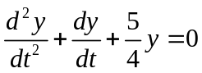,  the initial conditions are y(t=0)=0 and dy/dt(t=0)=1.Find the position  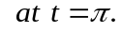(Gate 2018) | CO4 | K3 | Medium | Y | Homogeneous linear differential equation with constant coefficients | Complementary function (Roots are complex) | 4 | 6
43 | Apply Method of variation of parameters to solve:  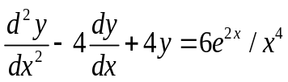 | CO4 | K3 | High | N | Variation of parameter method | P.I of a second order linear differential equation. | 4 | 9
44 | Apply Method of variation of parameters to solve:  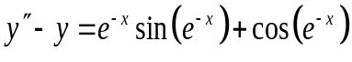 | CO4 | K3 | High | N | Variation of parameter method | P.I of a second order linear differential equation. | 4 | 9
45 | Apply Method of variation of parameters to solve  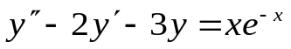 | CO4 | K3 | High | N | Variation of parameter method | P.I of a second order linear differential equation. | 4 | 9
46 | Solve:  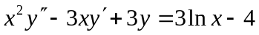 | CO4 | K2 | High | N | Homogeneous linear differential equation with variable coefficient | Cauchy-Euler equation | 4 | 9
47 | Solve:  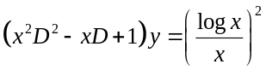  (GATE 2014) | CO4 | K3 | High | Y | Homogeneous linear differential equation with variable coefficients | Cauchy-Euler equation | 4 | 9
48 | Solve:  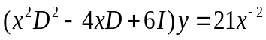 | CO4 | K3 | High | N | Homogeneous linear differential equation with variable coefficients | Cauchy-Euler equation | 4 | 9
49 | Solve the class of simultaneous differential equations:  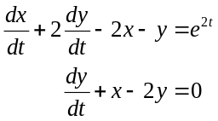 | CO4 | K3 | Medium | N | System of  linear differential equations. | Simultaneous linear differential equations with constant coefficient | 4 | 9
50 | Solve the set of simultaneous differential equations  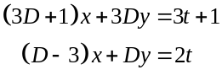 | CO4 | K3 | Medium | N | System of linear Diff. equations | simultaneous differential equations | 4 | 9
51 | Solve the simultaneous differential equation  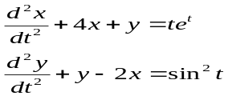  (GATE 2009) | CO4 | K3 | Medium | Y | System of linear Diff. equations | Simultaneous linear differential equations with constant coefficient | 4 | 9
52 | Find the current in the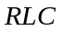  circuit given that 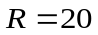 ohms, 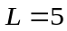henries, 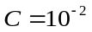 farad, 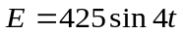volts. | CO4 | K3 | Medium | N | Application of Linear Diff. equations to Electric circuits | RLC CIRCUIT | 4 | 9
53 | Find the steady current in the RLC circuit with 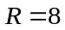 ohms, L=0.1 henries, C=1 farad, 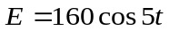 volts. | CO4 | K3 | Low | N | Application of Linear Differential Equations to Electric circuits | RLC CIRCUIT | 4 | 9
54 | An input voltage 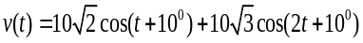 volts is applied to a series combination of resistance 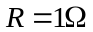 and an inductance . Find the resulting steady current in amperes. (GATE 2003) | CO4 | K3 | Low | Y | Application of Linear Differential Equations to Electric circuits | RLC CIRCUIT | 4 | 9

Signature of Course co-ordinator:
Signature of PC:
Signature of Dean:
IQAC:

Appendix II :
Bloom’s Taxonomy Levels Distribution of Questions in Question Bank
School of SBAS
Course Name : Linear Algerba and differential Equations Course Code : BMA201

Serial No. | Bloom’s Taxonomy Level | Percentage Distribution
1 | Knowledge | 10%
2 | Understand | 30%
3 | Apply | 60%

Signature of Course co-ordinator:
Signature of PC:
Signature of Dean:
IQAC:

Appendix III :
Bloom’s Taxonomy Levels Distribution of Questions in Question Bank
School of SBAS
Course Name : Linear Algerba and differential Equations Course Code : BMA201

Serial No. | Difficulty Level | Percentage Distribution
1 | Low | 20%
2 | Medium | 60%
3 | High | 20%

Signature of Course co-ordinator:
Signature of PC:
Signature of Dean:
IQAC:

